**Install a Web Server on Your EC2 Instance**

# This hands-on project is based on the work from,  https://github.com/RyanFitzgerald/devportfolio. You can find more information from this link.

**1. Use your local ubuntu VM to ssh your EC2 instance.**

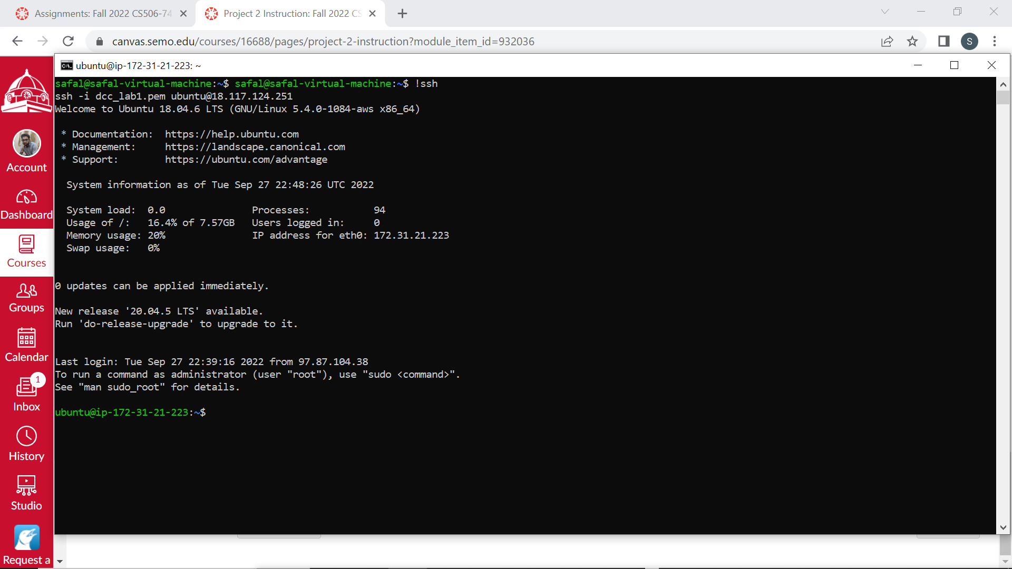

**2. Install Apache, MySQL & PHP on your EC2 instance.**

https://hostadvice.com/how-to/how-to-install-apache-mysql-php-on-an-ubuntu-18-04-vps/

$ sudo apt update

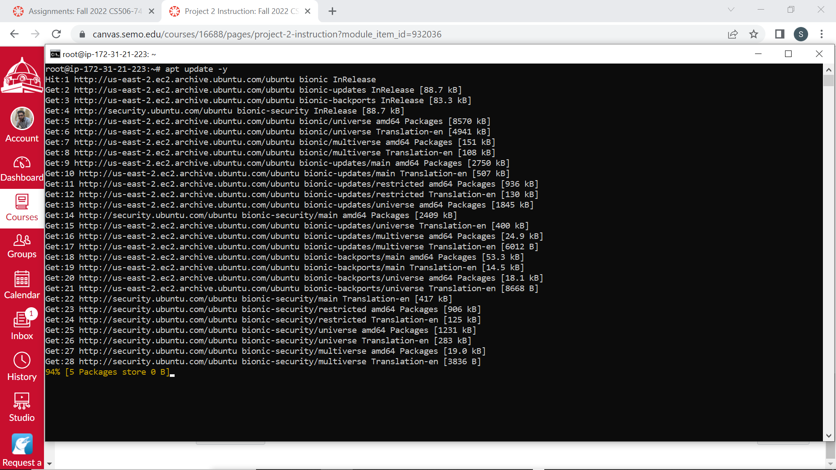

# install mysql server

$ sudo apt install mysql-server

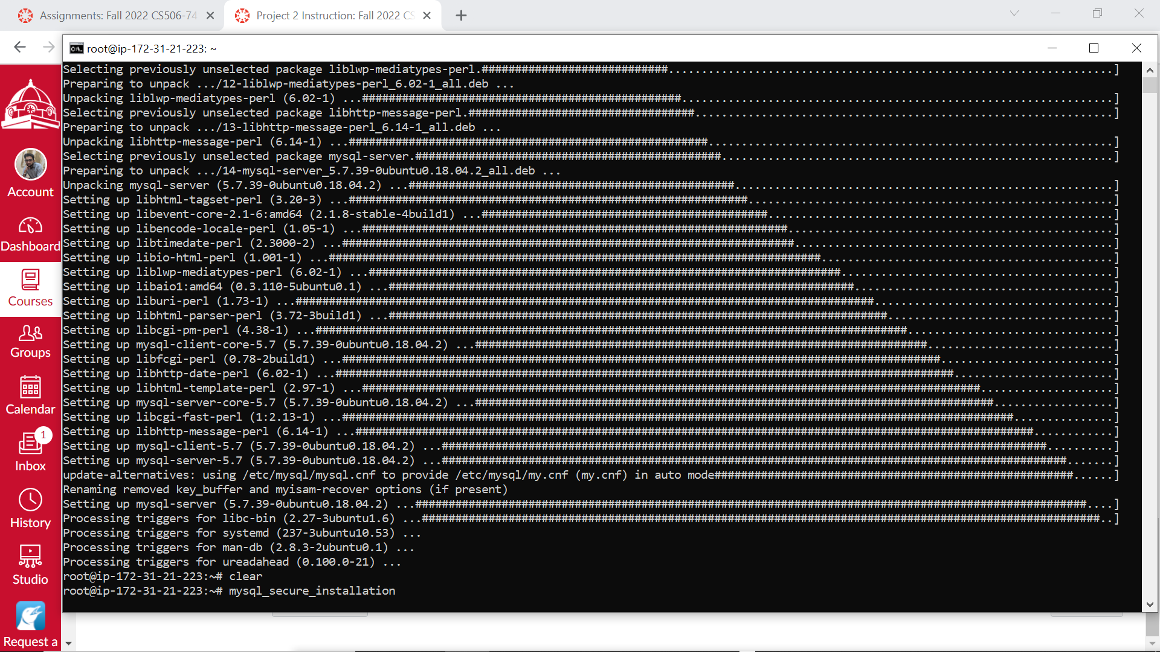

# test your mysql server, password is your EC2 instance's password

$ sudo mysql -u root -p

mysql> quit

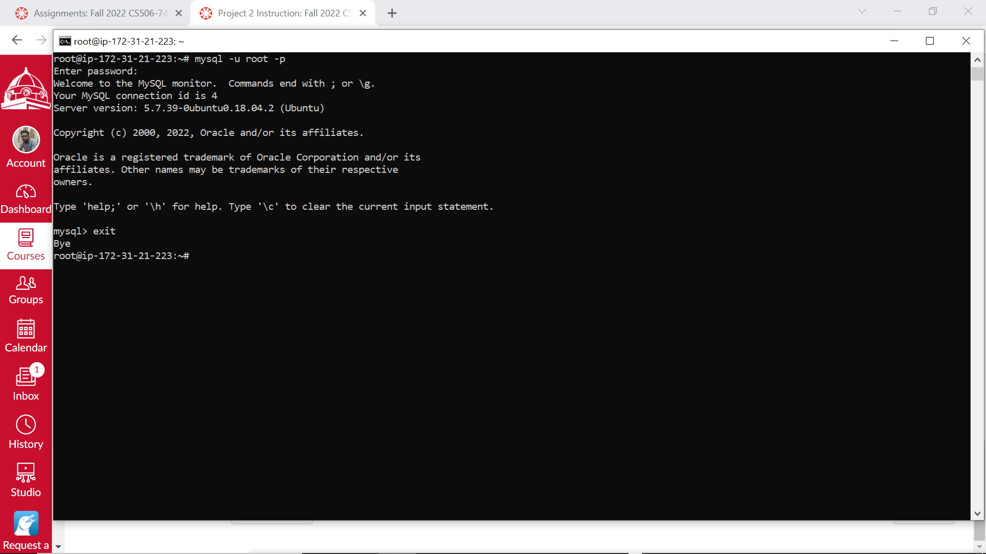

$ sudo apt install php libapache2-mod-php

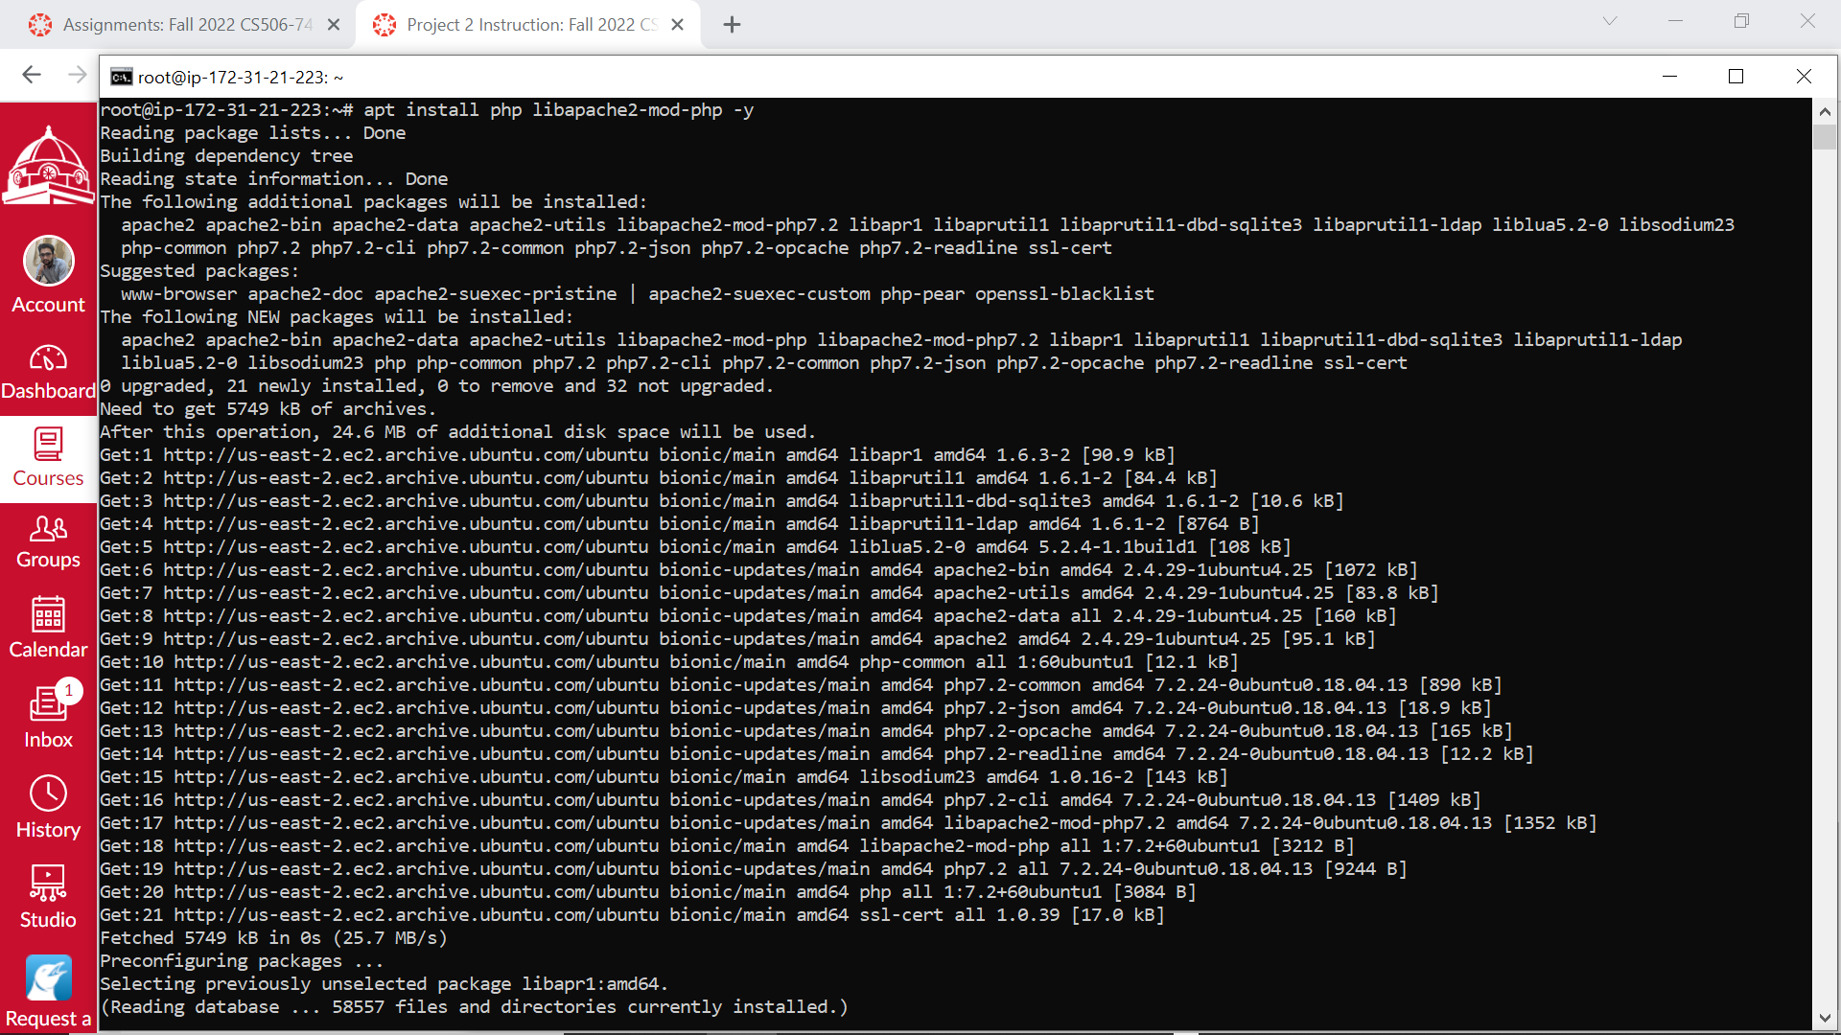

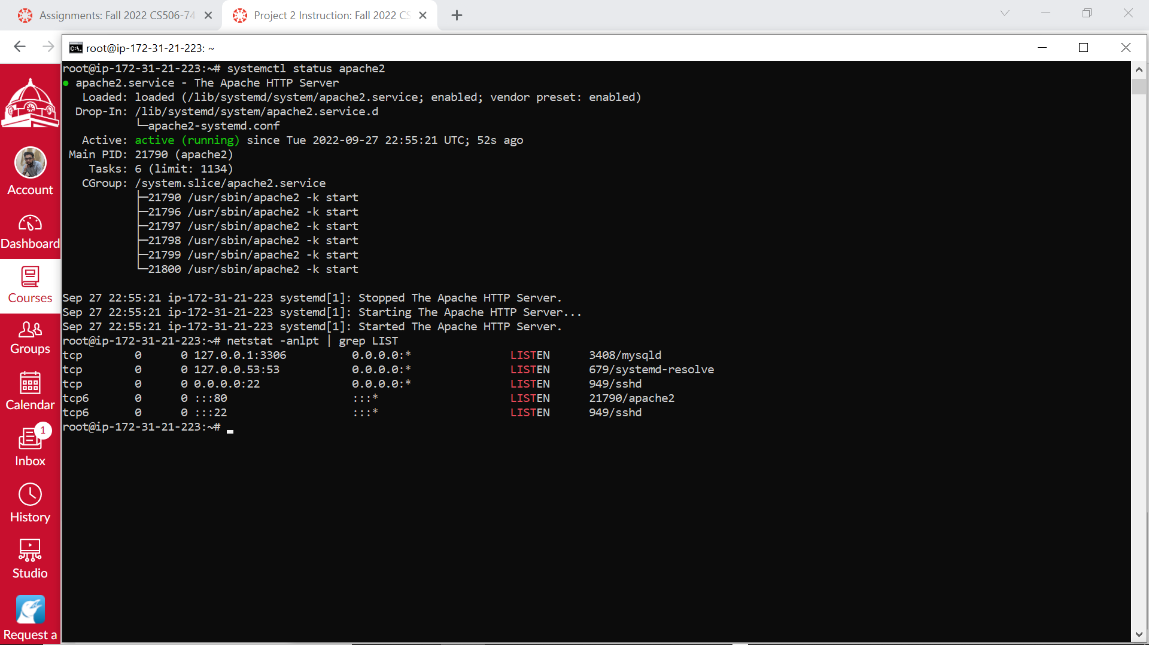

$ sudo nano /var/www/html/info.php

<?php

phpinfo();

?>

# Save file

CTRL+o

# Exit nano

CTRL+x

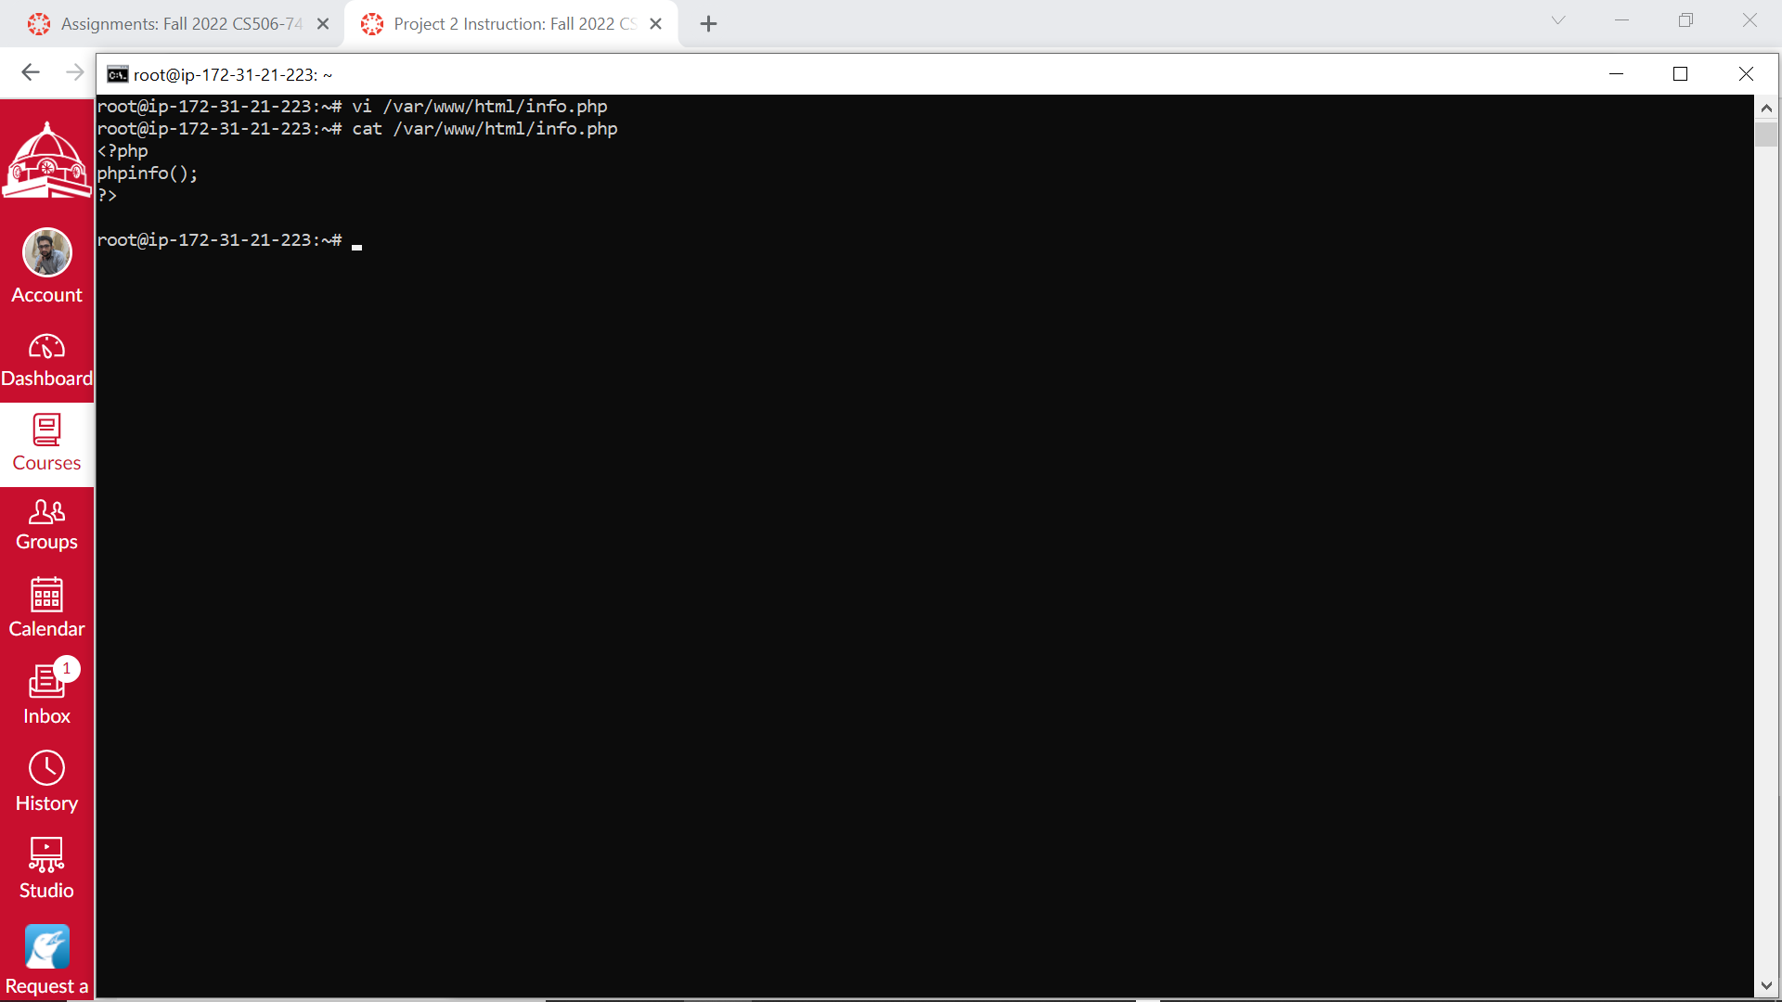

$ sudo systemctl restart apache2

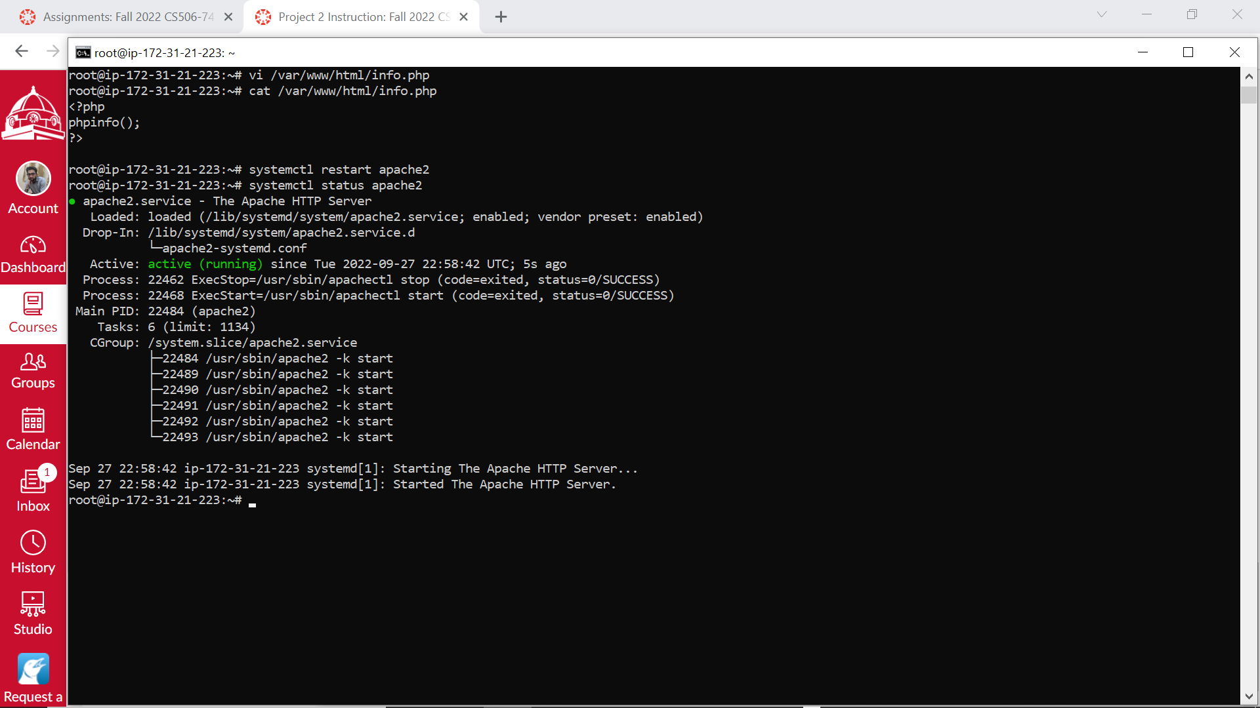

**3. Set file permissions for the Apache web server**

[https://docs.aws.amazon.com/AmazonRDS/latest/UserGuide/CHAP_Tutorials.WebServerDB.CreateWebServer.html (Links to an external site.)](https://docs.aws.amazon.com/AmazonRDS/latest/UserGuide/CHAP_Tutorials.WebServerDB.CreateWebServer.html)

# Add a new group www

$ sudo groupadd www

# Add the ec2-user "ubuntu" to the "www" group.

$ sudo usermod -a -G www Ubuntu

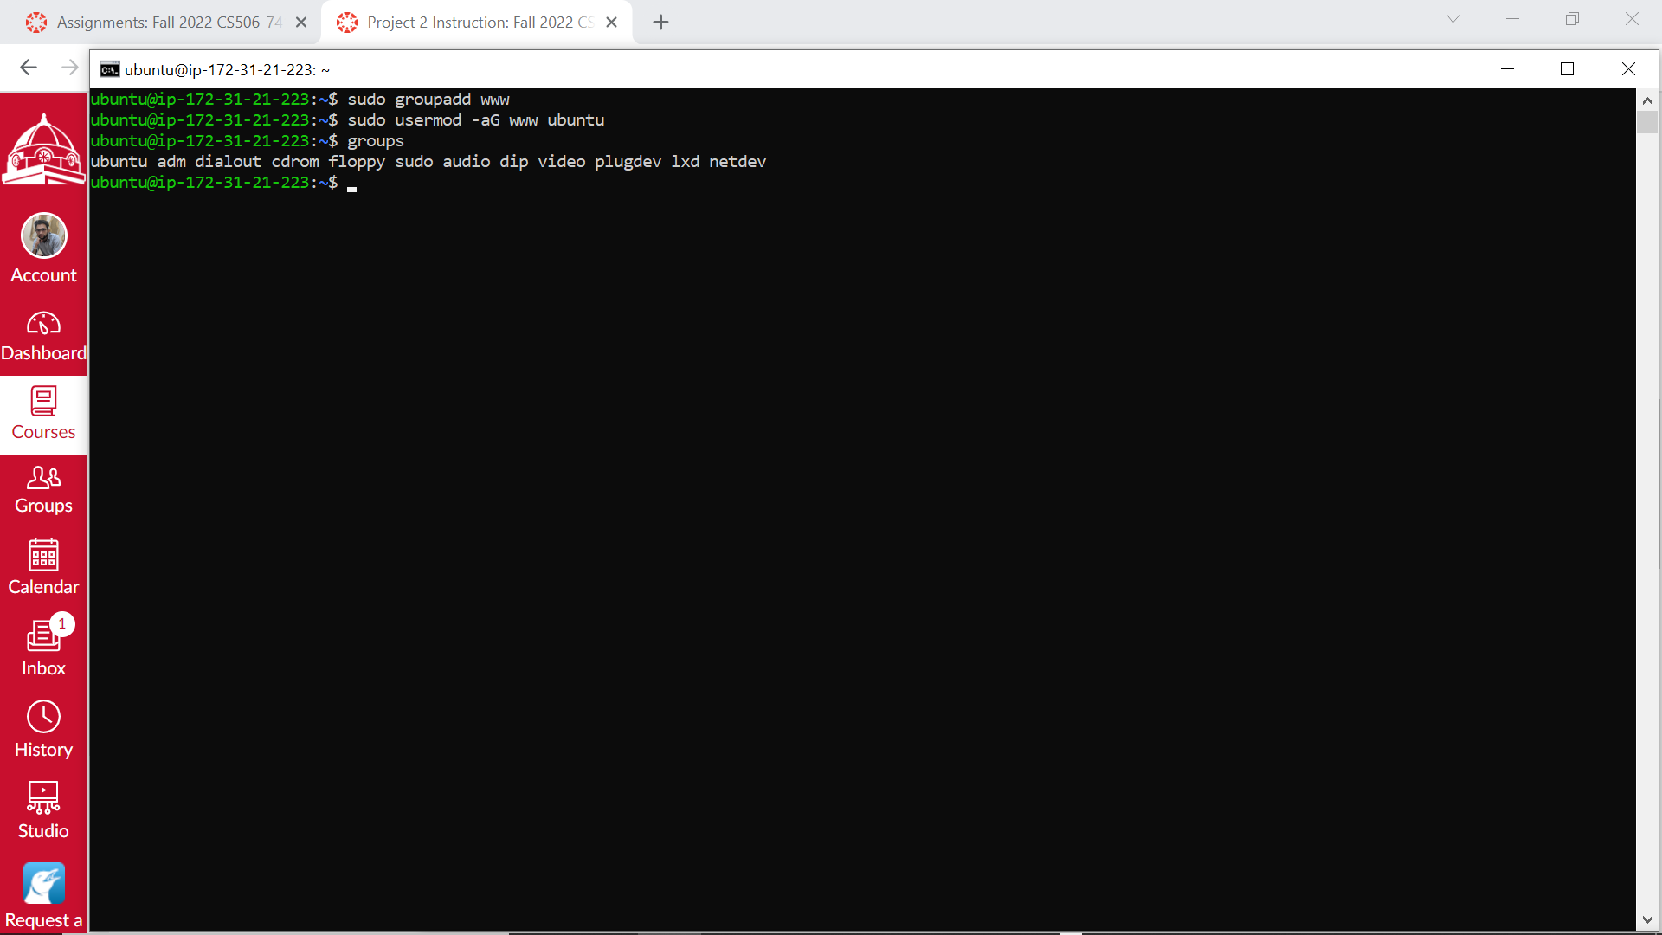

# Log out to refresh your permissions and include the new apache group.

$ exit

# ssh your EC2 instance again.

# Log back in again and verify that the apache group exists with the groups command.

$ groups

# Change the group ownership of the /var/www directory and its contents to the apache group.

$ sudo chgrp -R www /var/www

# Change the directory permissions of /var/www and its subdirectories to add group write permissions and set the group ID on subdirectories created in the future.

$ sudo chmod 2775 /var/www

$ find /var/www -type d -exec sudo chmod 2775 {} +

# Recursively change the permissions for files in the /var/www directory and its subdirectories to add group write permissions

$ find /var/www -type f -exec sudo chmod 0664 {} +

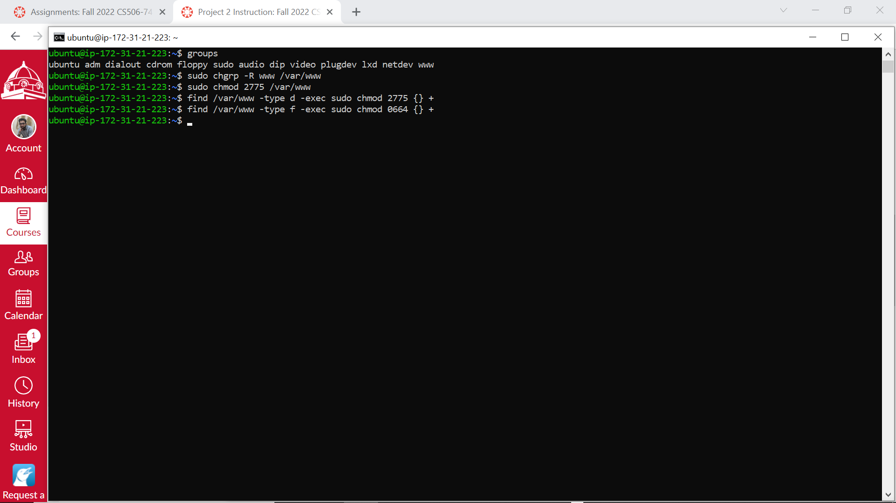

# Now, ec2-user "ubuntu" (and any future members of the apache group) can add, delete, and edit files in the Apache document root, enabling you to add content, such as a static website or a PHP application.

**4. Edit inbound rules of your EC2 instance.**

# Add a new rule to enabling Port 80 for the HTTP traffic on your EC2 instance.

Your AWS console -> Network & Security -> Security Groups -> -> Inbound rules -> Edit inbound rules -> Add rule -> Type -> HTTP -> Source type -> My IP -> Save rules

* If you can not ssh to your EC2 instance, you may need to create a new rule for your ssh traffic

Your AWS console -> Network & Security -> Security Groups -> -> Inbound rules -> Edit inbound rules -> Add rule -> Type -> SSH -> Source type -> My IP -> Save rules

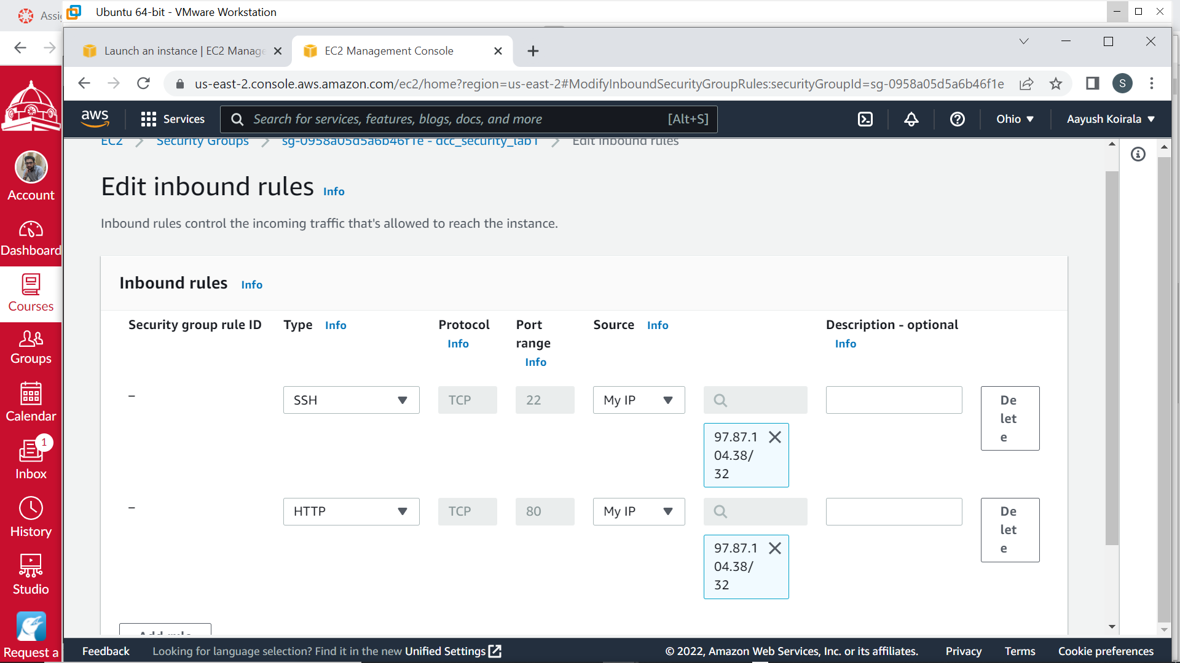

**5. Test your Apache Web server and PHP Server on your EC2 Instance.**

curl <http://localhost>

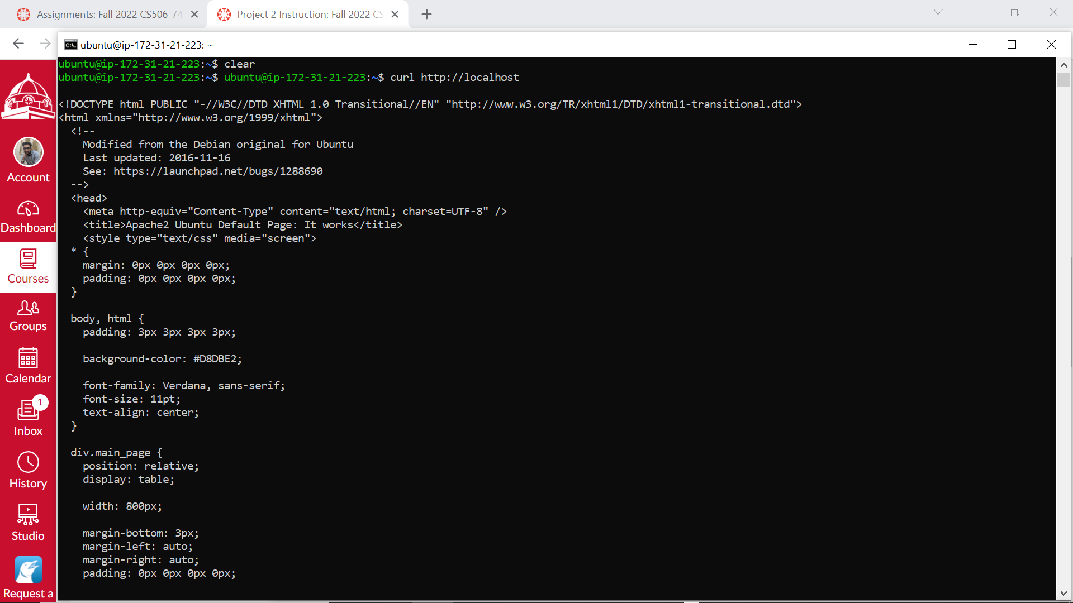

curl <http://localhost/info.php>

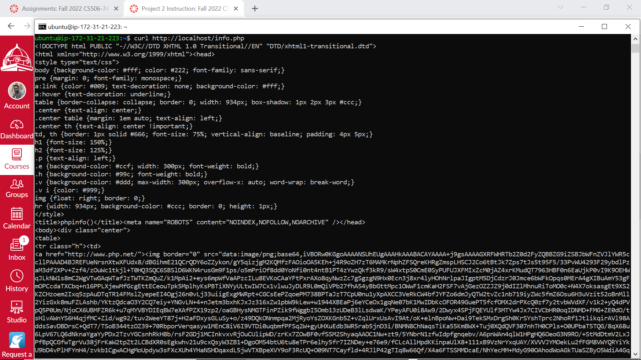

# You should have some feedback from your web server.

**6. Test your  Apache Web server and PHP Server on your EC2 Instance from your Local Computer**

**Test your  Apache Web server and PHP Server on your EC2 Instance from your Local ubuntu VM.**

curl <http://ec2-18-216-155-172.us-east-2.compute.amazonaws.com>

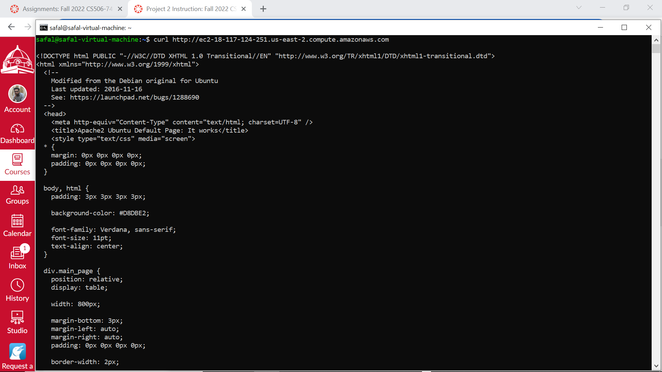

curl [http://ec2-18-216-155-172.us-east-2.compute.amazonaws.com/info.php (Links to an external site.)](http://ec2-18-216-155-172.us-east-2.compute.amazonaws.com/info.php)

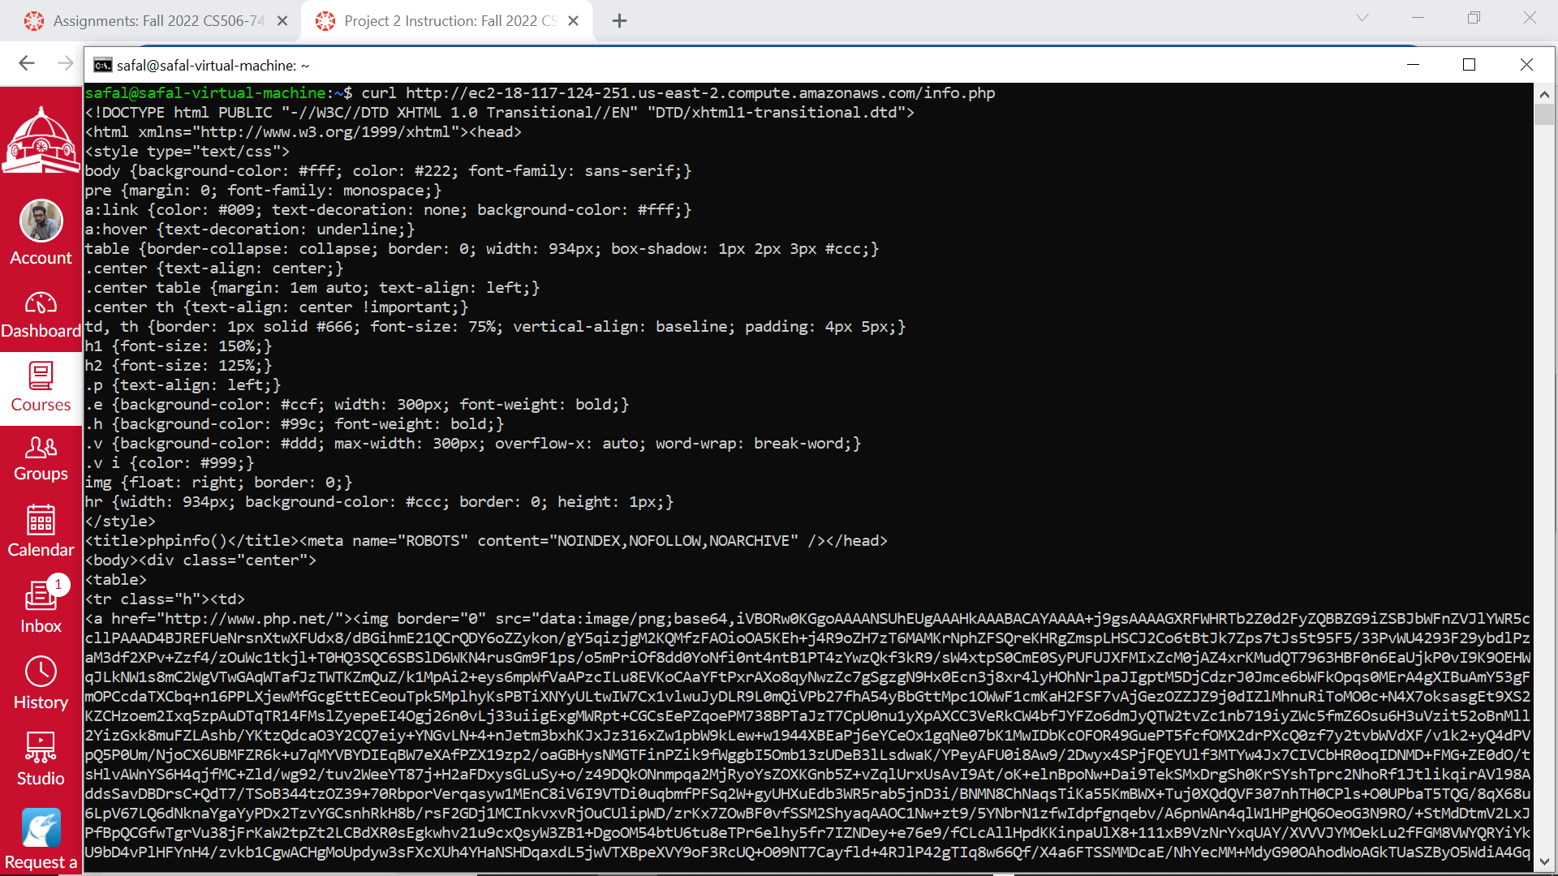

**Test your  Apache Web server and PHP Server on your EC2 Instance from your Local ubuntu VM.**

Browser -> [http://ec2-18-216-155-172.us-east-2.compute.amazonaws.com (Links to an external site.)](http://ec2-18-216-155-172.us-east-2.compute.amazonaws.com/)

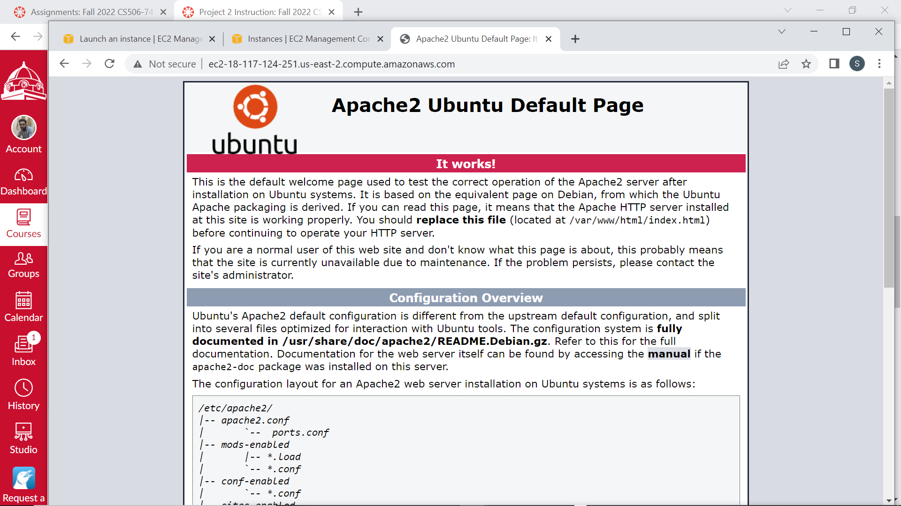

Browser -> <http://ec2-18-216-155-172.us-east-2.compute.amazonaws.com/info.php>

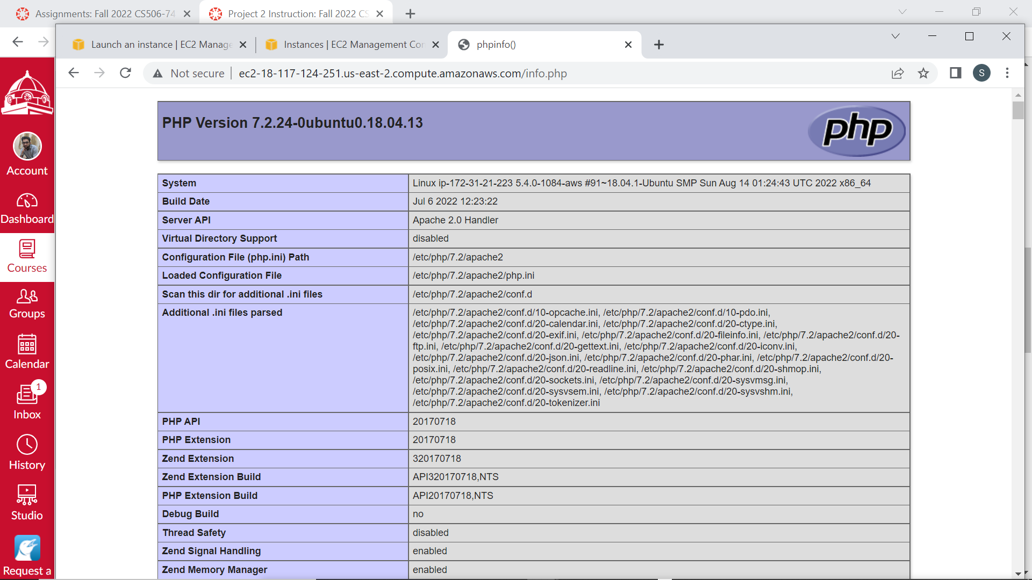

# Please replace with your host name.

# You should have some feedback from your web server.

**7. Copy a web server example to your EC2 instance.**

7.1 Download the file "devportfolio.zip" from Canvas to your local ubuntu VM.

7.2 scp the file to your EC2 instance.

In my case:

sudo scp -i ~/Downloads/cloud/aws_andy.pem ~/Downloads/cloud/devportfolio.zip ubuntu@ec2-18-216-155-172.us-east-2.compute.amazonaws.com:/var/www/html/

Please replace the pem file, the path of the zip file, and host name with yours.

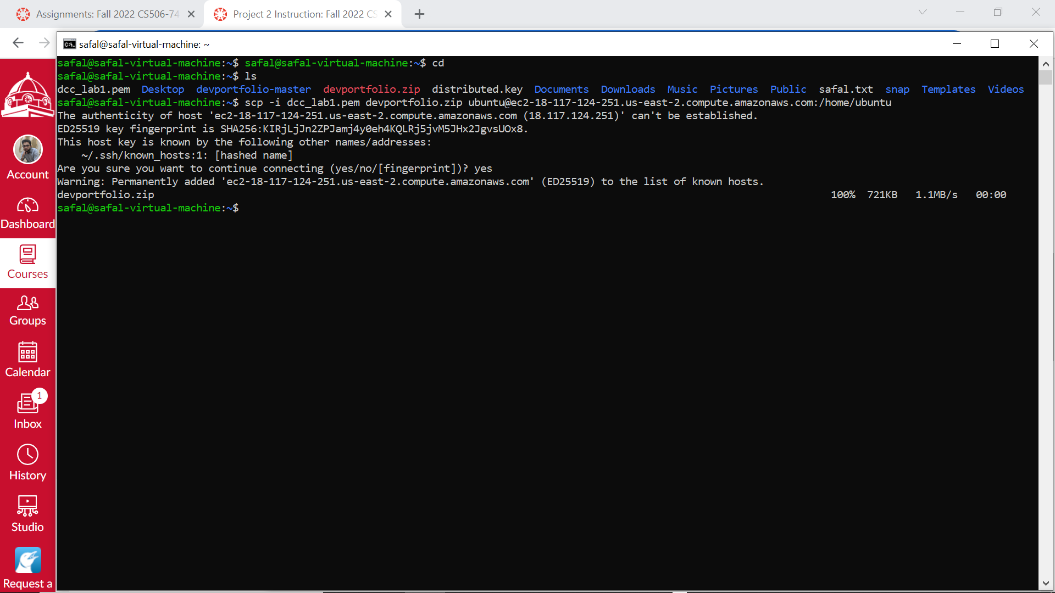

7.3 Unzip the zip file on your EC2 instance.

$ sudo apt install zip unzip

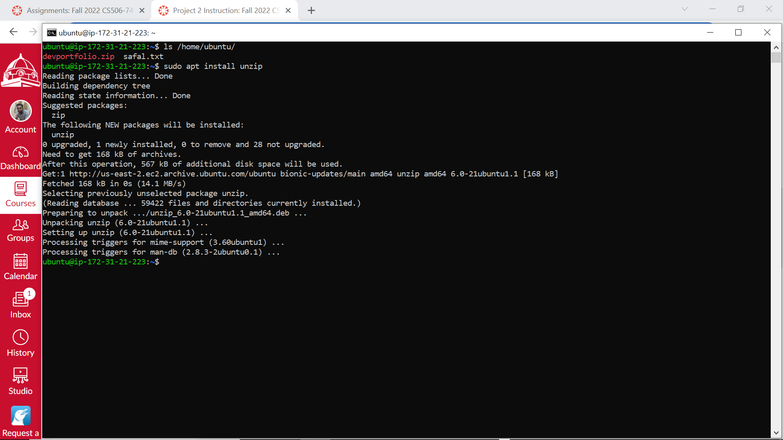

$ cd /var/www/html/

$ ls

# make sure you can find the file devportfolio.zip

$ unzip devportfolio.zip

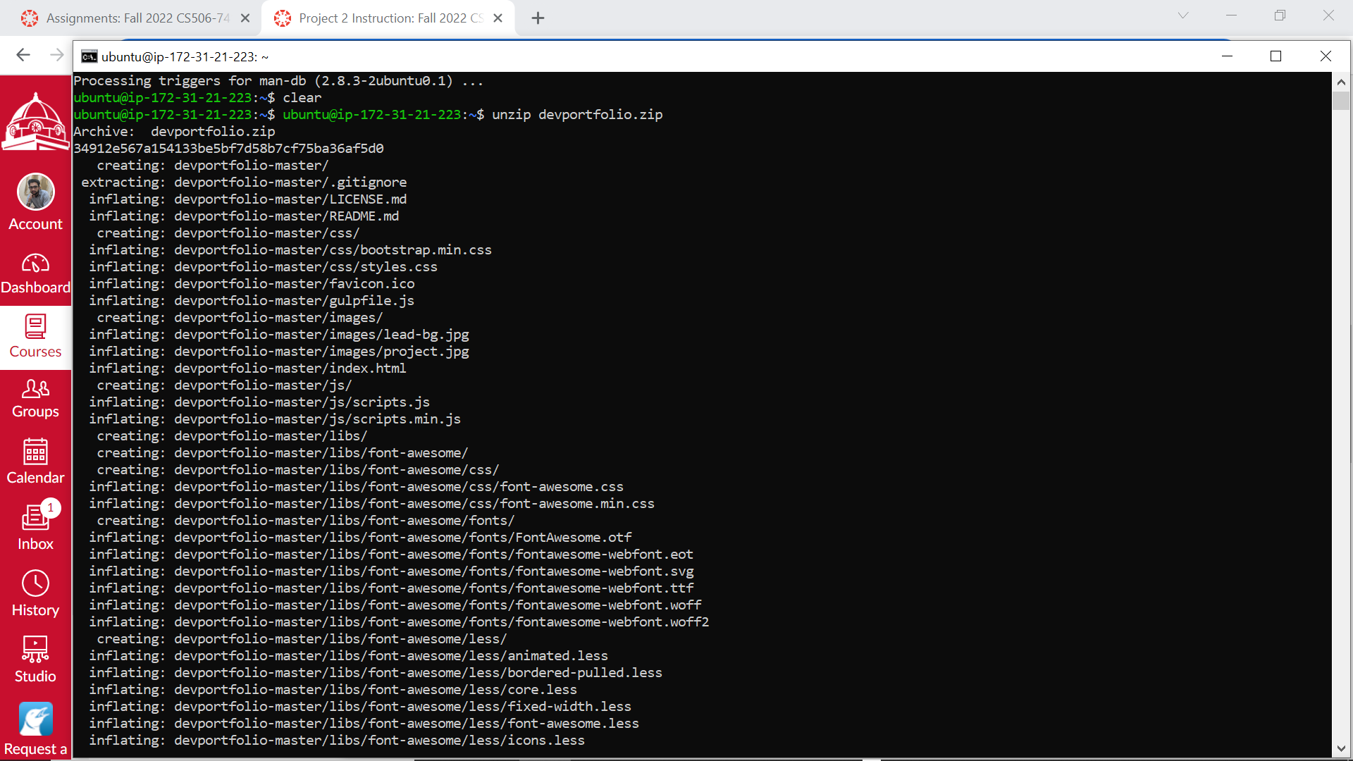

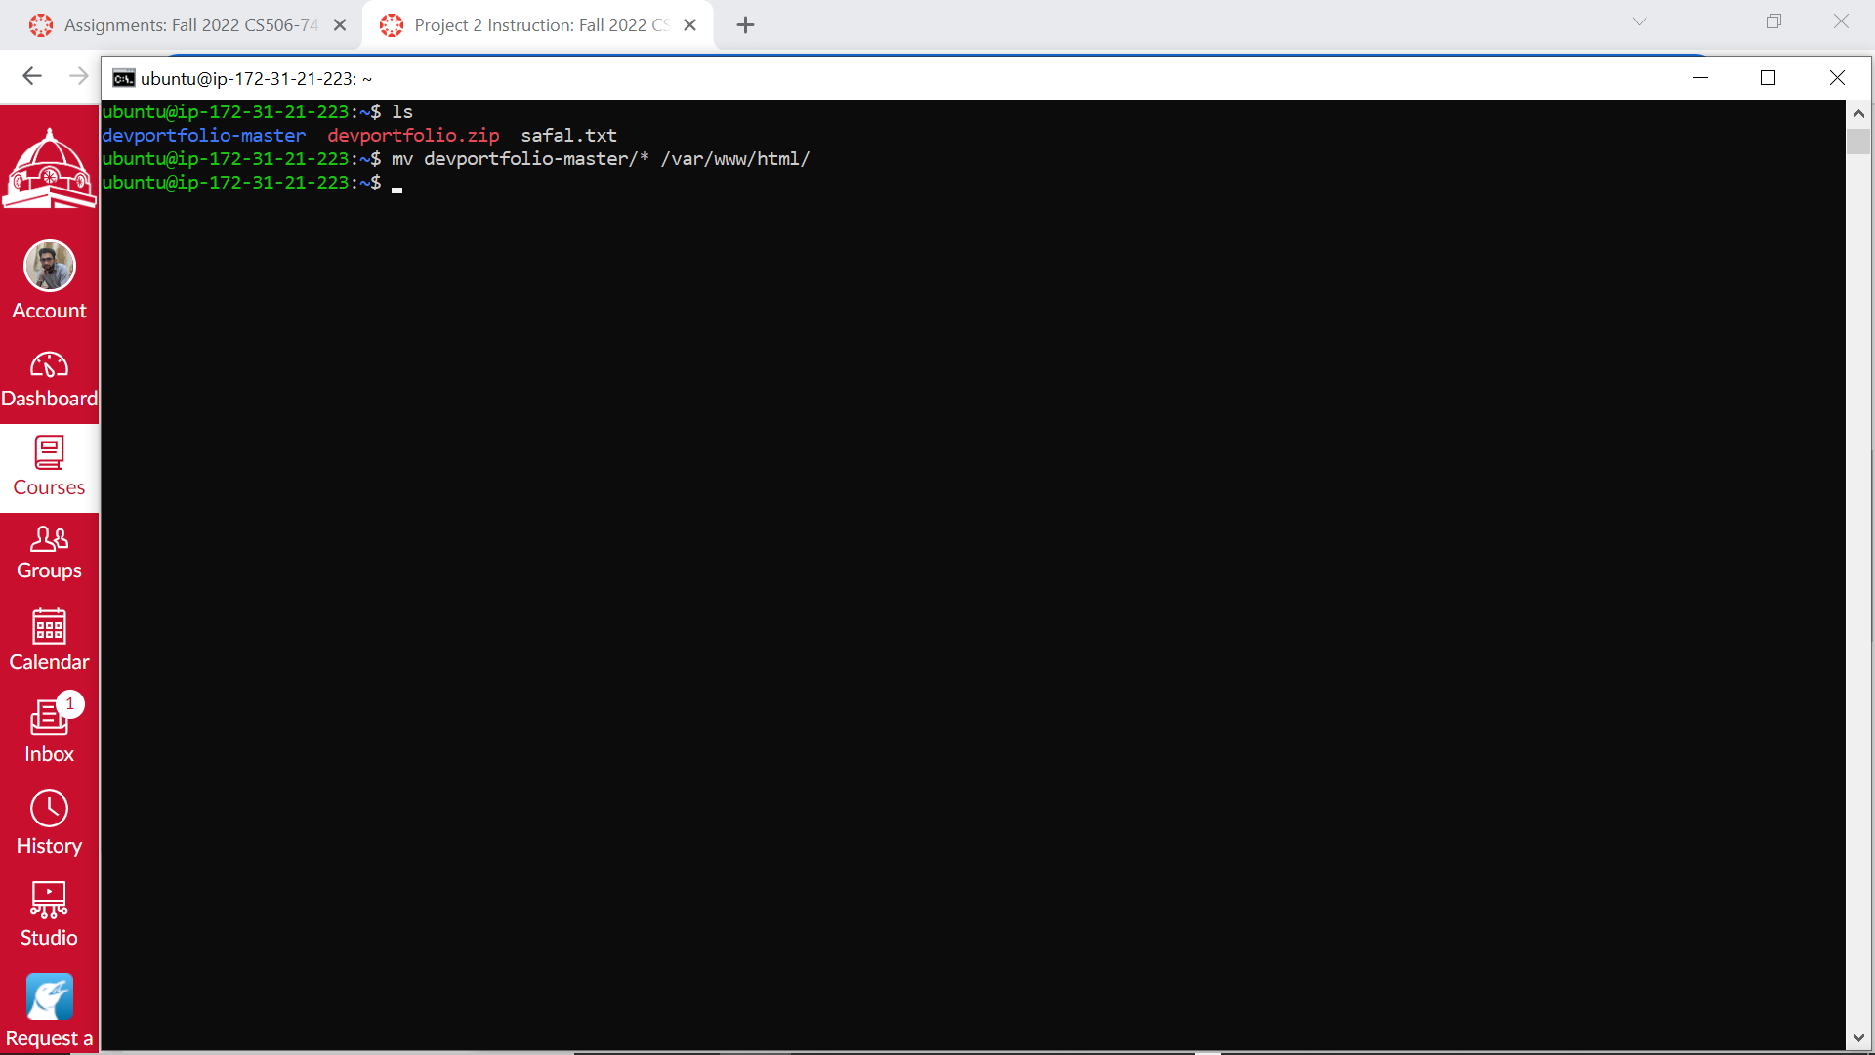

**8. Access your web server on your EC instance from your local windows machine.**

Browser -> <http://ec2-18-216-155-172.us-east-2.compute.amazonaws.com/devportfolio-master/index.html>

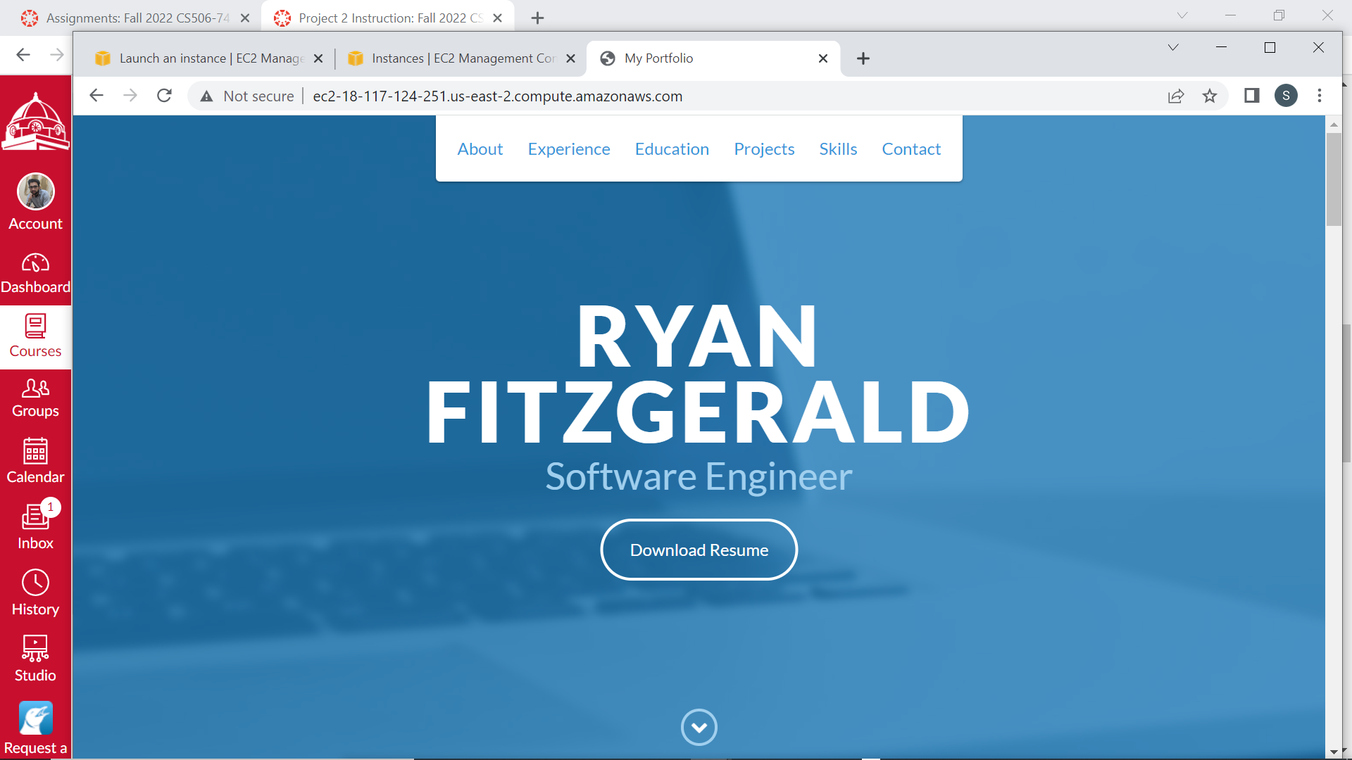

# Please replace with your host name.